TAFSIR SURAT AL-HUJURAT

- Surat al-Hujirat was revealed in Madinah
2. The Prohibition of making a Decision in advance of Allah and His Messenger; ordering
Respect towards the Prophet
3. Admonishing Those Who call the Prophet from behind Dwellings
4. Investigating the Reliability of the News conveyed by Wicked People
5. The Prophet's Decision is Better
6. Making Peace between Disputing Muslims
7. The Prohibition of mocking and ridiculing One Another
8. The Prohibition of Unfounded Suspicion
9. Accepted Repentance from Backbiting and Slander
10. All of Mankind are the Children of `Adam and Hawwa'
11.Honor is earned through Taqwa of Allah
12. There is a Difference between a Believer and a Muslim

1. The Surah was revealed in Al-Madinah



In the Name Of Allah, the Most Gracious, the Most Merciful

2. The Prohibition of making a Decision in advance of Allah and His Messenger; ordering Respect towards the Prophet
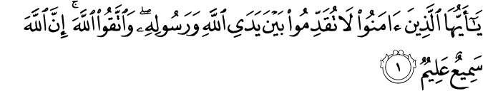

(1. O you who believe! Make not (a decision) in advance before Allah and His Messenger, and have Taqwa of Allah. Verily, Allah is Hearing, Knowing.)

Explanation
This verse ( ) illustrates ( ) that to over step the command ( ) of the prophet of impudence ( ) because the prophet is the nominee ( ) of God. Thus ( ) Muslims are commanded against haste ( ) in the presence of the Holy prophet to precede ( ) him, so much so that is forbidden ( ) to walk ahead ( ) of the Holy prophet. This is a general injunction ( ) which covers both word and action ( ) so behave ( ) with extreme ( ) caution ( ) neither openly overstepping the Holy Prophet nor covertly ( ) nursing ( ) a doubt.

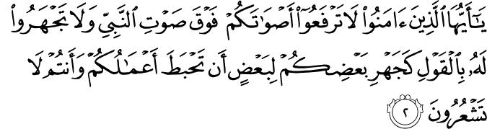

(2. O you who believe! Raise not your voices above the voice of the Prophet, nor speak aloud to him in talk as you speak aloud to one another, lest your deeds should be thwarted while you perceive not.)

Explanation
This second injunction ( ) the difference, regard ( ) and reverence ( ) due to the Holy Prophet (P.B.U.H).To raise ( ) your voice ( ) in his presence is a sin ( ) of such a magnitude ( ) the punishment ( ) of which is to lay waste ( ) all your good deeds ( ) and you would not be conscious ( ) of it.

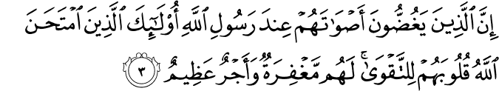

(3. Verily, those who lower their voices in the presence of Allah's Messenger, they are the ones whose hearts Allah has tested for Taqwa. For them is forgiveness and a great reward.)

Explanation
Those who speak softly in the presence of the Holy Prophet by their behavior provide proof ( ) of their fear ( ) of God, and a token ( ) of their reverence ( ) of the Holy Prophet such people shall be rewarded ( ) and blessed ( ) by ALLAH for their deeds ( ).

3. Admonishing Those Who call the Prophet from behind Dwellings


(4. Verily, those who call you from behind the dwellings, most of them have no sense.)

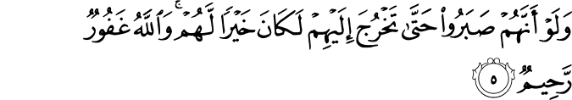

(5. And if they had patience till you could come out to them, it would have been better for them. And Allah is Forgiving, Most Merciful.)

Explanation
According to the generate custom ( ) to call the Holy Prophet outside ( ) by raising ones voice if ill mannered ( ) and impolite ( ) for the Holy Prophet is not like ordinary ( ) men, so, one is to await the Holy Prophet outside his house. So out of deference to the Holy Prophet such conduct was forbidden ( ).

4. Investigating the Reliability of the News conveyed by Wicked People
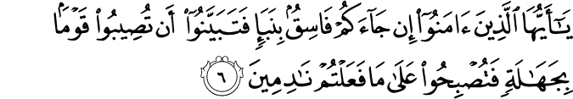

O you who have believed, if there comes to you a disobedient one with information, investigate, lest you harm a people out of ignorance and become, over what you have done, regretful.

Explanation
Do not heed ( ) what is said by evildoers ( ), because they are not trust worthily ( ) .Thus we have been commanded when a sinner ( ) bring some news, to first confirm ( ), otherwise unknowingly ( ) if you take some step it will cause ( ) you humiliation ( ). Thus command is universal applicable ( ) to all

5. The Prophet's Decision is Better
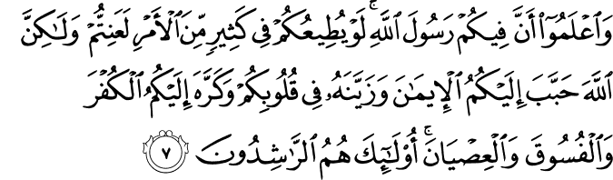

And know that among you is the Messenger of Allah . If he were to obey you in much of the matter, you would be in difficulty, but Allah has endeared to you the faith and has made it pleasing in your hearts and has made hateful to you disbelief, defiance and disobedience. Those are the [rightly] guided.
Explanation
The comanion ( ) where told that the messenger of GOD was in there midest ( ) who rules and judges ( ) according to the will of ALLAH he does not act ( ) on their advice ( ) otherwise they would have been caught ( ) up in difficulties ( ).

[It is] as bounty from Allah and favor. And Allah is Knowing and Wise.

Explanation
But after faith ( ) had been planted ( ) in their heart, ALLAH save them from difficulties. The clear meaning of this is, that in each matter ( ) the obedience ( ) of GOD and His Prophet ensures ( ) safety.

6. Making Peace between Disputing Muslims
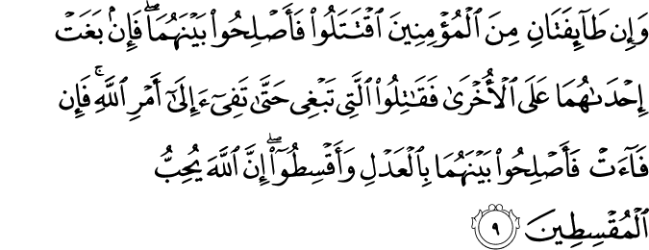

(9. And if two parties among the believers fall to fighting, then make peace between them both. But if one of them outrages against the other, then fight you (all) against the one that which outrages till it complies with the command of Allah. Then if it complies, then make reconciliation between them justly, and be equitable. Verily, Allah loves those who are the equitable.)

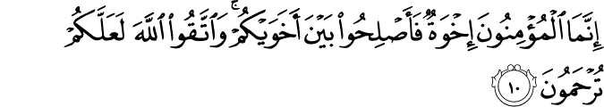

(10. The believers are but a brotherhood. So make reconciliation between your brothers, and have Taqwa of Allah that you may receive mercy.)

Explanation
The Muslims are brothers to each other and it is the duty ( ) of a Muslim to bring about peace between two brothers or two groups of Muslims using all their goodwill ( ) and influence to this end and if one of the parties does not accept ( ) the ruling ( ) the Muslim should standup against the rebel ( ), and combat ( ) him, but one he repent ( ) of his conduct ( ), then bring about peace and understanding between them.

7. The Prohibition of mocking and ridiculing One Another
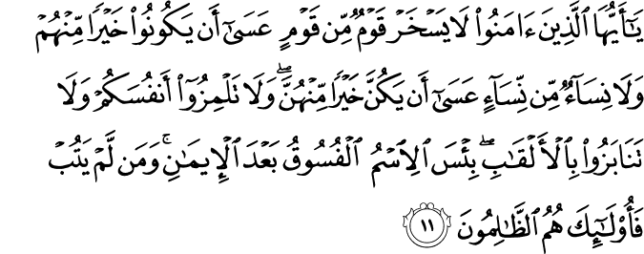

(11. O you who believe! Let not a group scoff at another group, it may be that the latter are better than the former. Nor let (some) women scoff at other women, it may be that the latter are better than the former. Nor defame yourselves, nor insult one another by nicknames. Evil is the name of wickedness after faith. And whosoever does not repent, then such are indeed wrongdoers.)

Explanation
The Muslim man should not ridicule ( ) another Muslim. they are prevented ( ) because perhaps ( ) the person whom you are humiliating, may be better then you, because ALLAH alone ( ) has the knowledge of lightness, inner state and feelings, there after women are addressed, no women should laugh at another women, perhaps the women may be better in sight of ALLAH
It is forbidden to taunt ( ) another Muslim, for taunt an invective ( ) hurt feelings, which creates dissension ( ) and hatred ( ) among Muslims it is implies( ) you are all descended ( ) for one father and one mother ADAM and EVE ( ) therefore to taunt a human being like yourself cannot be permissible that is to say his failing ( ) is your failing do not call names to a Muslim or tease ( ) him in this manner, he should feels shame ( ) apart ( ) from these this command includes such name as one would not like for oneself like, Lame ( ) walleyed ( ) blind ( ) etc. since these all hurts, feeling, we have been forbidden from using them.

8. The Prohibition of Unfounded Suspicion
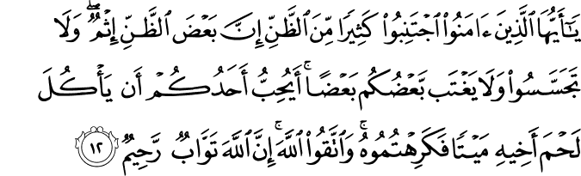

(12. O you who believe! Avoid much suspicion; indeed some suspicion is sin. And spy not, neither backbite one another. Would one of you like to eat the flesh of his dead brother You would hate it. And have Taqwa of Allah. Verily, Allah is the One Who forgives and accepts repentance, Most Merciful.)

Explanation
O Muslim keep yourself safe from mutual ( ) misunderstanding, for suspicion ( ) is the root of strife ( ) that is to say unless there are proper reason or news confirmed do not think evil ( ) of any person this can also become the source ( ) of discord ( ) which cause love and sincerity to disappear from social life, some suspicion are sinful ( ), for to thank evil of any man without confirmation is a sin, this injunction is due to purpose of preventing ( ) people from undue suspicion, for probe ( ) about a person, Thus Muslim has been forbidden to probe the action of any person, do not occupy ( ) yourselves in probing ( ) him. You must not been bent ( ) on investigating the circumstances ( ) of any individual for give this rise to evil ( ). Near the conclusion ( ) the phrase ( ) fear GOD then ALLAH will forgive ( ) you your sin, for he is merciful ( ) despite ( ) our sin.

9. Accepted Repentance from Backbiting and Slander

Backbiting

On all ethical ( ) ills, the worst ( ) ill, widely prevalent ( ) in our society is backbiting ( ) simply stated ( ) backbiting means slandering ( ) or speaking ill of others behind their back. Allah has strongly warned ( ) the Muslim to obtain ( ) from this evil. The Holy Quran say:
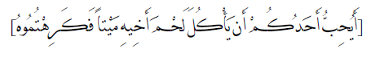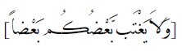

“Do not allow yourselves to speak ill of one another behind your back, would any one of you like to eat the felts of his dead brother.”
Backbiting bears ( ) resemblance ( ) to a man who relishes ( ) the meat of a dead brother, because the man spoken ill of its absent and cannot defend ( ) himself. This besides, and nurses ( ) mutual ( ) hatred ( ) and animosity ( ). Moreover ( ) the person discussed and criticized ( ) becomes stubborn ( ) as his faults ( ) are widely published ( ) According to one Hadith, The Holy Prophet (P.B.O.H) while referring ( ) to the incidents ( ) of “MIRAJ” AND SAID that he saw a group of individual with copper ( ) nails ( ) who were busy in scratching ( ) their faces and chests I asked Gabrail “who are they?” He replied “They are the ones who eat peoples flesh ( ) and distort ( ) their respectable ( ) images.
Islam declares ( ) fault ( ) finding permissible only in two instance ( ) first while supporting ( ) an oppressed ( ) individual against an oppress and secondly, to expose ( ) the fraudulent ( ) practices ( ) of an impost ( ) So that people become aware ( ) of his doings.

10. All of Mankind are the Children of `Adam and Hawwa'
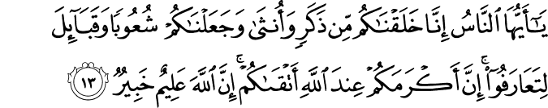

(13. O mankind! We have created you from a male and a female, and made you into nations and tribes that you may know one another. Verily, the most honorable of you with Allah is that (believer) who has At-Taqwa. Verily, Allah is All-Knowing, All-Aware.)
Explanation
Almighty ( ) Allah enjoins ( ) us to be God fearing, we have given a single origin ( ) to your creation then we spread you over the earth and divided you into tribes ( ) and groups ( ) so that you can distinguish ( ) each other, not for you to take pride ( ) in your origin. This verbal pride, wealth ( ) and power ( ) have to value ( ) before God, this does not bring honor ( ) to you. The real honors is to be God fearing, so amongst you, he who is most God fearing he is the most honorable before God.

11. Honor is earned through Taqwa of Allah

12. There is a Difference between a Believer and a Muslim
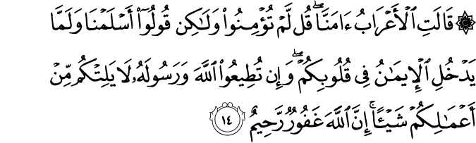
(14. The bedouins say: "We believe.'' Say: "You do not believe. But say, `We have submitted,' for Faith has not yet entered your hearts. But if you obey Allah and His Messenger, He will not decrease anything in reward for your deeds. Verily, Allah is Forgiving, Most Merciful.'')

Explanation
This verse has related that the Banu Asad came during the time of famine ( ) and state ( ) their claim ( ) on having accepting, Islam, There up on this verse was revealed ( ) that if you have accepted Islam place your matter in the hands of ALLAH and his Apostle for this is the sign of faith, otherwise to count acceptance of Islam as a favors is unbecoming. Now if unknowingly you have done so, repent, ALLAH will grant you pardon ( ) for he is the most merciful.

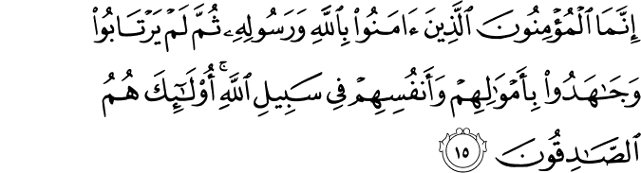

(15. Only those are the believers who have believed in Allah and His Messenger, and afterward doubt not but strive with their wealth and their lives for the cause of Allah. Those! They are the truthful.)

Explanation
True faith and abstinence ( ) have been described ( ) the sign of faith is never being in doubt after having accepted the faith, and when the time comes, to spend our wealth to obtain ( ) the will of God, and if the need arrive to risk ( ).Our life for Islam and God and do not seek ( ) recompense ( ) for it, are the signs of the truly Muslim and really faithful.

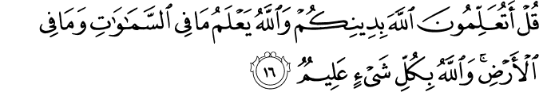

(16. Say: "Will you inform Allah of your religion while Allah knows all that is in the heavens and all that is on the earth, and Allah is All-Aware of everything.'')

Explanation
The divine word ( ) again gave guidance to He Bani Asad that they must have faith that God knows all circumstances and thoughts ( ) and what to say of them. Allah has the greatest knowledge of everything in the heavens ( ) and on earth. But till ( ) the day of reckoning ( ) they apply to every such ( ) person who seeks to make Islam the instrument ( ) of worldly attainments ( ).

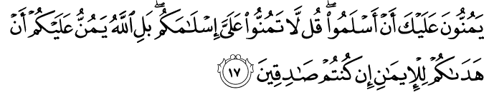

(17. They regard as a favor to you that they have embraced Islam. Say: "Do not count your Islam as a favor to me. Nay, but Allah has conferred a favor upon you that He has guided you to the Faith if you indeed are true. '')

Explanation
The people of all tribes are addressed who consider their acceptance of Islam as a favor of Allah and His Apostle. Actually they should count it a favor of ALLAH and his Apostle that they have been saved from perversity ( ) and from doom ( ) and also from waywardness ( ) and destruction ( ) in this world.

(18. "Verily, Allah knows the Unseen of the heavens and the earth. And Allah is the All-Seer of what you do.'')

Explanation
Those people have been shown guidance who pay lip service to Islam but do not obey God and his Prophet from the core ( ) of their hearts. All such people have been warned that nothing in the skies or the face of the earth in hidden ( ) from God and he sees all, and the demand ( ) of faith is to sub serve ( ) ourselves wholly to the commands of God, and to surrender ( ) them our personal options is the sign of faith and sincerity.

